**Economic Vitality and Population Health:**

**Unraveling Life Expectancy and Causes of Death in the Top 10 Projected Economies**

1. Background & Intro

In exploring the complex interplay of economic growth, healthcare infrastructure, and disease patterns, our project examines how prosperity influences consumption habits and subsequently impacts major non-communicable diseases such as cardiovascular, cancer, diabetes, and respiratory conditions. We focus on understanding the correlation between shifts in consumption patterns and key health indicators, raising questions about life expectancy, causes of death, and nuanced relationships.

This research is significant for uncovering insights into the intricate connections between economic prosperity and health outcomes. Through descriptive statistics, visualization of leading causes of death, predictive modeling, and analysis of variations across genders and regions, our project aims to provide a comprehensive understanding of the dynamics shaping global health scenarios. Ultimately, this exploration holds the promise of expanding knowledge and informing strategies at the intersection of economics and public health.

2. Research Objects:

1. Present precise life expectancy statistics categorized by country and gender, offering a snapshot of current global health trends.

2. Employ visualizations to showcase the prominent causes of death, emphasizing distinctions among countries and regions, and providing a narrative of health disparities.

3. Construct a regression model to predict life expectancy variations, delving into the intricate factors influencing health outcomes across diverse countries and regions.

4. Explore the nuanced interplay between life expectancy and causes of death by clustering them about the economic development of countries, unraveling the complex dynamics at the intersection of health and prosperity.

3. Data Set

Our comprehensive analysis relies on meticulously curated datasets from esteemed institutions, chiefly the World Health Organization (WHO) and Our World in Data, supplemented by Gross Domestic Product (GDP) information from the World Bank.

Dataset 1: [Life Tables by Country](https://www.who.int/data/gho/data/indicators/indicator-details/GHO/gho-ghe-life-tables-by-country)

With a total of 243,390 rows, this dataset meticulously details age-specific death rates. It specifically delves into the mortality dynamics between the initiation of age group x and the commencement of the subsequent age group x+n, where n denotes the interval of the age group. This dataset is a valuable resource for comprehending mortality patterns within different age brackets across various countries.

Dataset 2: [Number of deaths attributed to non-communicable diseases, by type of disease and sex](https://www.who.int/data/gho/data/indicators/indicator-details/GHO/number-of-deaths-attributed-to-non-communicable-diseases-by-type-of-disease-and-sex)

Comprising 43,920 records, this dataset offers insights into mortality rates and causes of death attributed to non-communicable diseases. The information is categorized by disease type, gender, and age group, spanning multiple countries and geographical regions. With a detailed breakdown by individual countries, this dataset provides a nuanced understanding of mortality trends associated with non-communicable diseases.

Transformed Dataset:

Encompassing a diverse array of health-related indicators and crucial economic insights, the datasets include key factors like life expectancy, GDP, and 2022 population figures. Following an initial exploration, we honed our dataset, emphasizing essential columns such as 'Location' (country), 'Period' (year), 'Dim1' (Sex), 'Dim2' (Age Group), and 'FactValueNumeric' (numeric values of Life Expectancy-related indicators).

Our analytical focus is directed towards the top 10 economies, comprising China, the United States, India, Japan, Germany, Russia, Brazil, Indonesia, the United Kingdom, France, and Mexico (11 countries in total).

Variables:

* Location: Country   
  (China, India, US, Japan, Germany, Russia, Brazil, Indonesia, UK, France, and Mexico)
* Period: Year   
  (2000, 2005, 2010, 2015, 2019)
* Sex: Male and Female
* Age_Group: 19 ranged age groups

( <1 year, 1-4 years, 5-9 years, 10-14 years, 15-19 years, 20-24 years, 25-29 years, 30-34 years, 35-39 years, 40-44 years, 45-49 years, 50-54 years, 55-59 years 60-64 years, 65-69 years, 70-74 years, 75-79 years, 80-84 years, 85+ years)

* FactValueNumeric: the value of below indicators.
  + *Indicators* (consistent across all datasets):
* nMx - age-specific death rate between ages x and x+n
* nqx - probability of dying between ages x and x+n
* lx - number of people left alive at age x
* ndx - number of people dying between ages x and x+n
* nLx - person-years lived between ages x and x+n
* Tx - person-years lived above age x

Dataset 3: GDP info

4. General Finding

Temporal Evolution of Average Life Expectancy Across Countries (2000-2019)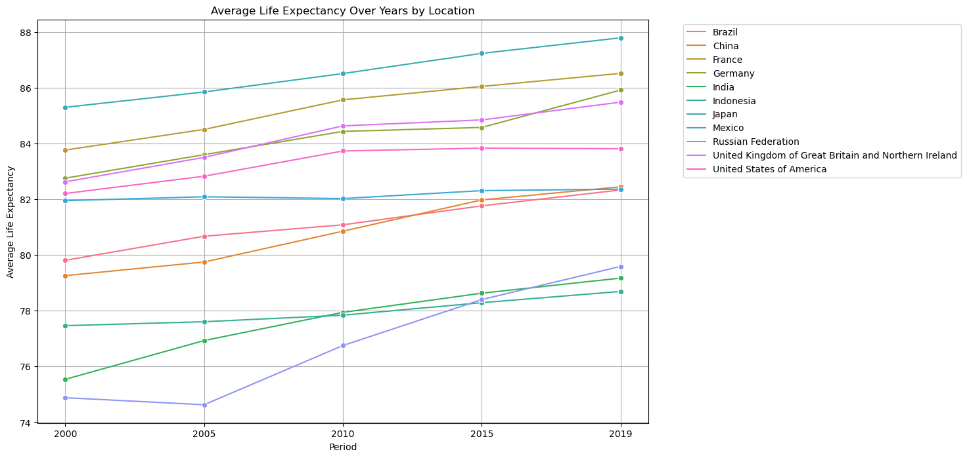

This graph tracks the shift in average life expectancy from 2000 to 2019 across diverse locations. Japan consistently leads, followed by France, while the United Kingdom and Germany contend for the third and fourth spots, with the United States securing fifth place.

Key changes include Mexico's descent from sixth to eighth place, and Brazil and China claiming the sixth and seventh positions. Russia makes a notable ascent from eleventh to ninth. India maintains the tenth spot, but Indonesia slips from ninth to eleventh.

In summary, countries fall into two broad categories upon analysis: "First World," encompassing Japan, France, Germany, the UK, and the US, which consistently uphold higher life expectancy and secure the top 5 positions from 2000 to 2019; and "emerging powers," including the remaining six countries, displaying an upward trend in life expectancy over the same period.

Temporal Evolution of GDP Across 11 Countries (2000-2019)

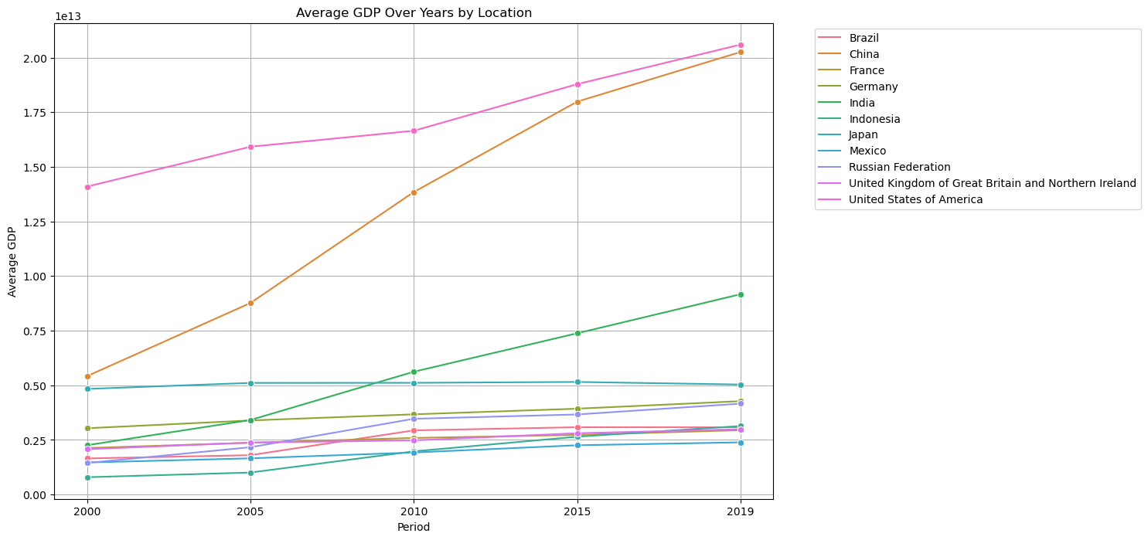

This graph illustrates the GDP trends of 11 countries from 2000 to 2019. Notably, the United States, China, and India experienced substantial and sharp increases, signaling robust economic growth. Meanwhile, Russia, Brazil, and Indonesia exhibit more moderate increases, suggesting a steady but less pronounced economic ascent. The remaining countries demonstrate a stable and consistent trajectory, experiencing relatively marginal changes in their GDP over the specified period.

Distribution of Death Rates from Four Non-communicable Diseases Across Countries

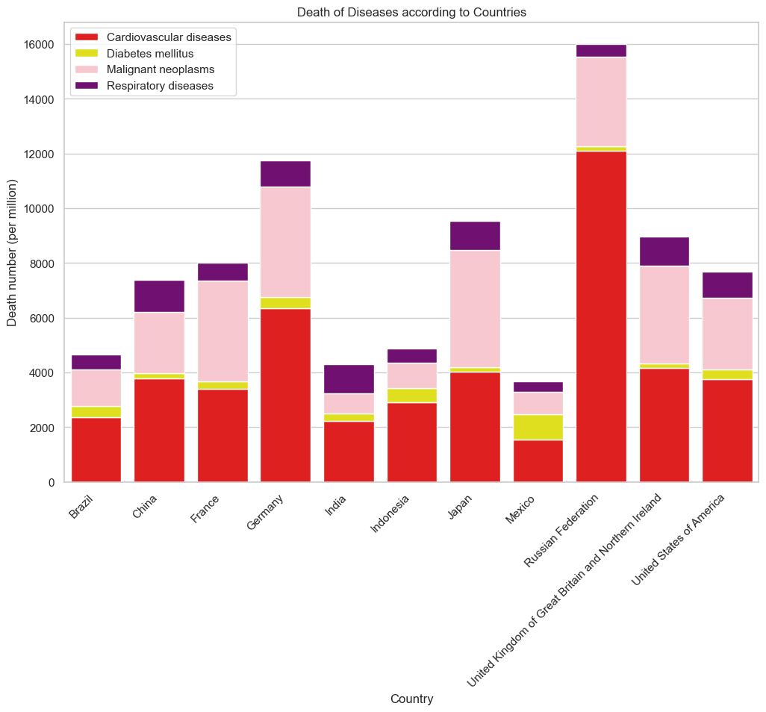

This graph provides an overview of death rates related to four non-communicable diseases across various countries. Cardiovascular diseases and Malignant Neoplasms (cancer) emerge as predominant causes of death, revealing distinct patterns. Russia and Germany exhibit a significant proportion of cardiovascular deaths, while France, Japan, and the UK experience higher incidences of Malignant neoplasm (cancer) deaths. Additionally, Mexico and Indonesia demonstrate elevated death rates from Diabetes, while China and India exhibit higher death rates from respiratory diseases.

Remarkably, Russia stands out with an overall higher death rate compared to other major economies. In our forthcoming cluster analyses, we aim to delve deeper into this dataset, unveiling nuances, differences, and relationships among countries regarding non-communicable disease mortality.

5. Modeling Finding

**Life Expectancy for each Country in 2030:**

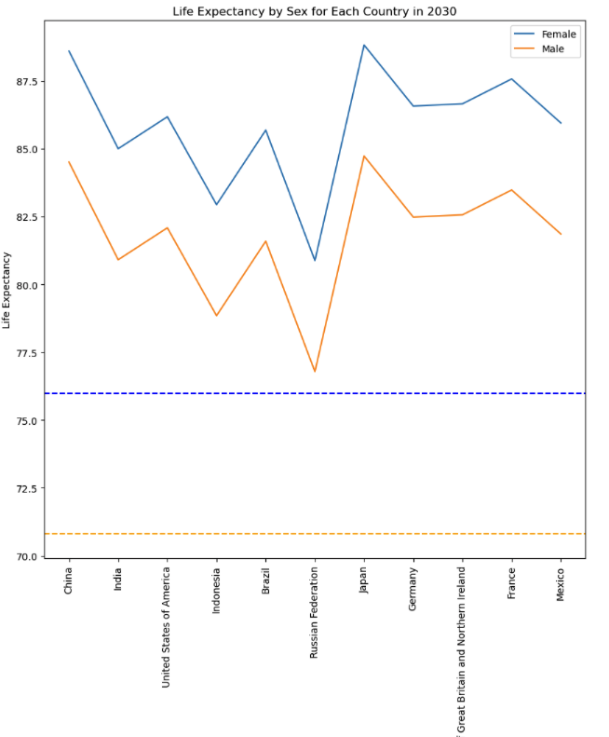

The provided graph illustrates the life expectancy trends for a selected group of countries. The orange and blue lines depict the average global life expectancy, highlighting that all high-GDP economies exhibit life expectancies surpassing the worldwide average for the year 2030.

**Table showing the sequence for Life Expectancy in the year 2030 for the top economies-**

|  |  |  |
| --- | --- | --- |
| **Country Name** | **Female Life Expectancy** | **Male Life Expectancy** |
| Japan | 88.8 | 84.7 |
| China | 88.6 | 84.5 |
| France | 87.6 | 83.5 |
| Great Britain and Northern Ireland | 86.7 | 82.6 |
| Germany | 86.6 | 82.5 |
| United States of America | 86.2 | 82.1 |
| Mexico | 85.9 | 81.9 |
| Brazil | 85.7 | 81.6 |
| India | 85 | 81 |
| Indonasia | 83 | 78.9 |
| Russian Federation | 80.9 | 76.8 |

In summary, by the year 2030, Japan is projected to boast the highest life expectancy, followed closely by China and France. In contrast, the Russian Federation is anticipated to have the lowest life expectancy, with India and Indonesia ranking just above in the descending order presented in the table above.

6. Clustering

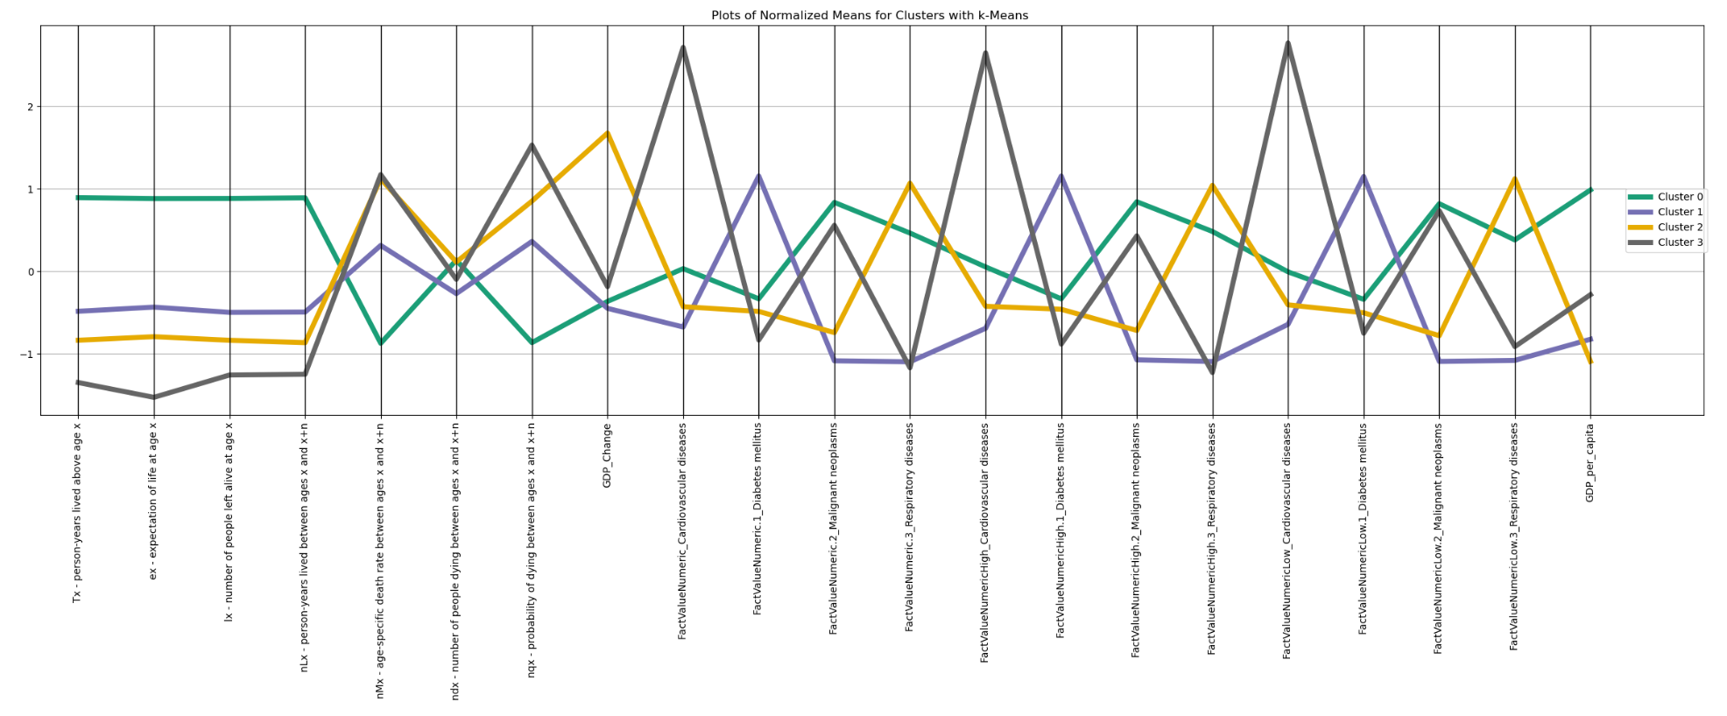

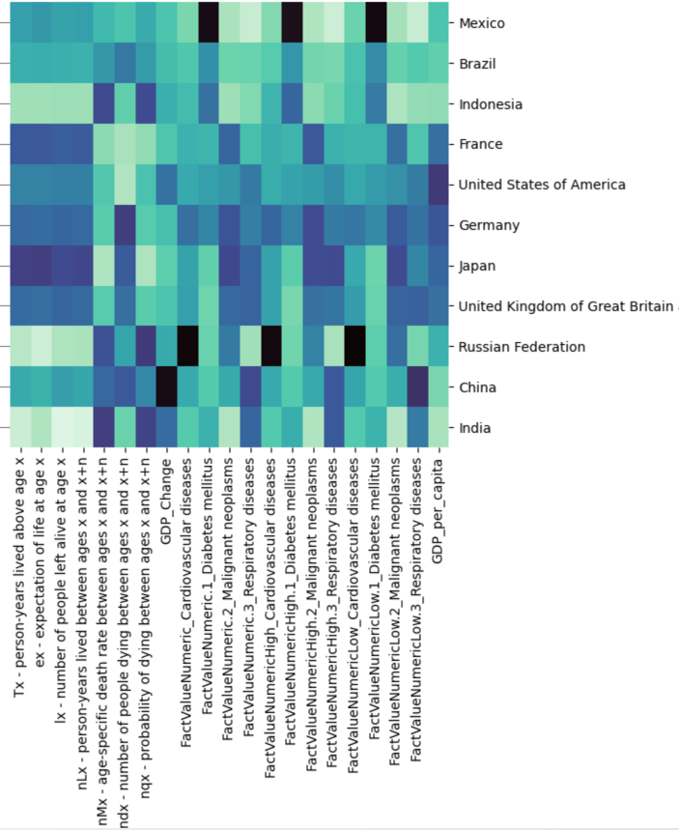

|  |  |  |
| --- | --- | --- |
| **Named Cluster** | **Countries**  **Differentiated Non-Communicable Disease** | **Description** |
| ***First World*** | France, Germany, Japan, UK, USA  ***Non-communicable Cause of Death: Cancer***   * Advanced healthcare infrastructure and technology lead to better detection and reporting of cancer cases. * Longer life expectancy increases the likelihood of developing cancer over a lifetime. * Lifestyle factors such as diet and environmental exposures might contribute to cancer incidence. | Higher life expectancy (ex), lower age-specific death rates (nMx).  Higher GDP and possibly positive GDP change.  Lower values in health-related factors (e.g., cardiovascular diseases, diabetes, malignant neoplasms, respiratory diseases).  Generally more developed and healthier economies. |
| ***Mid-Tier*** | Brazil, Indonesia, Mexico  ***Non Non-communicable cause of Death: Diabetes***   * Economic conditions may lead to dietary patterns that are conducive to diabetes. * Limited access to healthcare facilities and education on preventive measures for diabetes. * A potentially younger population with less emphasis on preventive health measures. | Lower life expectancy, higher age-specific death rates.  Lower GDP and possibly negative GDP change.  Possibly higher values in health-related factors.  Potentially representing less developed economies with health challenges. |
| ***Emerging Superpowers*** | China, India  ***Non-communicable Cause of Death: Respiratory Disease***   * Rapid industrialization and urbanization may lead to increased air pollution, contributing to respiratory diseases. * Occupational hazards in emerging industries might expose people to respiratory risks. * Growing urban populations may be living in crowded conditions, increasing the transmission of respiratory infections. | Values in between Cluster First-World and Cluster Mid-Tier for life expectancy and age-specific death rates.  Moderate GDP and GDP change.  Health-related factors may vary but tend to be more moderate compared to Cluster Mid-Tier.  Represents countries with intermediate levels of development and health indicators. |
| **Cold War Superpower** | Russia  ***Non-Communicable Cause of Death: Heart Disease***   * Historical lifestyle factors, such as diet and stress, could contribute to cardiovascular issues. * Economic challenges may limit access to healthcare services, impacting cardiovascular disease prevention and management. * Cold climate might influence cardiovascular health, as extreme temperatures can affect blood pressure and heart function. | Lower life expectancy and higher age-specific death rates, similar to Cluster Mid-Tier.  GDP and GDP change may vary, but likely to be lower.  Health-related factors may show mixed patterns.  Potentially representing a country with lower development and health challenges. |

Conclusion

Consistent Life Expectancies and Stable Order: Across all countries, life expectancies remain high, reflecting overall advancements in global health. The anticipated shift in life expectancy rankings does not materialize, emphasizing the enduring nature of health patterns across these nations.

GDP Influence: Higher GDP countries consistently exhibit higher life expectancies, underscoring the impact of robust health infrastructure and effective prevention programs on overall well-being.

Gender Disparity: Females consistently outlive males, aligning with a well-established global health trend.

Russian Discrepancy: Notably, Russia's life expectancy lags behind other developed nations, warranting further investigation and targeted interventions. Cold weather and political climates influence life expectancies, revealing a nuanced interplay between environmental and socio-political factors. Further research can focus on comparing the incidence of cardiovascular diseases and life expectancy in Russia with other cold regions, examining the potential impact of climate and political factors on residents' health.

Respiratory Challenges: China and India face higher respiratory deaths, suggesting a need to address air pollution and occupational risks associated with rapid industrialization. Similar issues may arise in other rapidly urbanizing developing countries. Further research can focus on comparing air quality and potential health impacts in these two countries and other developing nations.

Future Projections: Anticipated rank order for 2030 life expectancy reveals Japan, France, and others leading the chart, offering valuable insights for future health planning.

In summary, our analysis provides a comprehensive understanding of the intricate dynamics influencing life expectancies. Economic, gender, and environmental factors play pivotal roles. As we project into the future, these insights will guide our efforts in shaping health policies and interventions.

Recommendations according to Diseases

1. Cardiovascular Disease:

* Implement targeted prevention strategies, emphasizing lifestyle modifications and public health initiatives.
* Enhance early detection through regular screenings and the integration of advanced diagnostic technologies.

2. Respiratory Diseases:

* Improve air quality through environmental initiatives, emphasizing the reduction of air pollution and promotion of clean energy sources.
* Manage occupational risks associated with respiratory health through workplace safety regulations and awareness programs.
* Educate the public on the importance of respiratory health, emphasizing lifestyle choices and pollution avoidance.

3. Cancer:

* Increase awareness campaigns on cancer prevention, focusing on lifestyle choices, vaccination programs, and risk factor mitigation.
* Utilize technology for early detection, investing in advanced screening tools and telemedicine solutions.
* Ensure widespread access to cancer treatment, promoting equitable healthcare services and affordability.

4. Diabetes & Metabolic Disorders:

* Implement comprehensive education programs promoting healthy lifestyles, with a focus on balanced nutrition and physical activity.
* Encourage regular health check-ups for early detection and intervention, emphasizing the importance of routine medical examinations and preventive care.

5. Global Collaboration:

* Establish a collaborative platform for sharing best practices globally, fostering an exchange of knowledge and expertise among nations.
* Foster international partnerships to address common health challenges collectively, promoting joint research initiatives, resource-sharing, and coordinated response strategies.